The Grace School

*Family Handbook*



15448 Lucia Riverbend Hwy

Stanley, NC 28164

The Grace School is an equal opportunity employer and provider.

Welcome to The Grace School!

Thank you for choosing The Grace School for your early childhood education needs. We are dedicated to providing you and your child with high-quality care and early childhood education services in a secure and stimulating environment that encourages each child to explore, learn, and develop at their own pace. We offer early childhood programs for children ages six weeks to five years of age, as well as after school enrichment for kindergarten through fifth-grade students. Our program’s curriculum goals focus on developmental milestones at each stage of development and utilize developmental assessment to assure that each child’s goals are met. We maintain a low teacher to child ratio in all of our classes and our teachers are required to meet the highest education standards set forth by the NC Division of Child Development. We look forward to working with you and your child as we watch your child blossom and reach their fullest potential!

Amy Simmons

Owner / Director

Operational Procedures

**Ages of Children Served**

The Grace School accepts and has classrooms equipped and designed to create ideal learning environments for children ages 6 weeks to 12 years old. We have one infant classroom, one toddler classroom, one 2-year-old classroom, one 3-year-old classroom, and two Pre-K classrooms for an NCPK program and a classroom for our own Pre-K program. Our after school program utilizes our NCPK classroom after the NCPK day has finished and children have been picked up. NCPK children who stay after the school day, are apart of our after school program.

**Hours and Days of Operation**

The Grace School is open Monday through Friday from 6:30 am to 6:00 pm, except for the following days where we will be closed throughout the year.

**Closed for Holidays**

* New Year’s Day - January 1st
* Good Friday - Friday before Easter Sunday
* Memorial Day - Last Monday in May
* Independence Day - July 4th
* Labor Day - First Monday in September
* Thanksgiving Day - Fourth Thursday and Friday in November
* Christmas Eve - December 24th
* Christmas Day - December 25th
* One additional day according to the calendar

*If a holiday should fall during a weekend, the closing schedule will be posted in advance of a change.

**\*\**Our teachers are paid for holidays, so full tuition is expected for those weeks.***

**Enrollment**

Available spots are filled on a first come first serve basis in all of our classrooms. We also maintain a waiting list for each classroom and spots will be filled after those individuals have been contacted. A registration fee of $45 must be paid in order to be placed on the waiting list; otherwise, we will not be able to secure or guarantee your child’s spot in a classroom.

Additionally, the following paperwork must be submitted prior to your child’s first day in the classroom:

1. Child’s Application
2. Signed Discipline and Behavior Management Policy
3. Completed Parent/Guardian Signature Page

Medical Reports and Immunization records are due within 30 days of your child’s start date. Please make an appointment early enough for your child to be seen in this time frame.

**Classroom Orientation**

We encourage families to schedule an orientation time with your child’s teachers and director upon enrollment. This gives children and families the opportunity to get used to their new learning environment. Classroom orientation is limited to one day and is offered free of charge.

**Staff Requirements**

All of our staff are required to take and pass a criminal background check, be up to date in their medical reports to determine eligibility to work with children, and pass a TB test. Additionally, our staff members are all certified in First Aid and CPR for all ages.

Our teachers are required to meet the highest education standards that are set by the NC Division of Child Development depending on their position and age groups that they work with. Every year, teachers and staff are also required to take a certain amount of hours for training and additional courses to continue their professional development, which has also been determined by the position and the hours they work.

**Reporting Suspected Abuse and Neglect Policy**

North Carolina law requires childcare professionals to report any instance of suspected child abuse or neglect to the department of social services. Such reports are not accusations but rather requests that the appropriate agency check on the wellbeing of a child. In most cases, concerns would be discussed with families before (or at the time of) making such a report.

**Nutrition**

Our center is ***peanut-free*** due to some children having severe allergies. Please do not allow your child to bring food into the classroom during drop off. All items that are brought to the center from home for parties must be store-bought and peanut-free.

The Grace School participates in the USDA food program which ensures that your child is receiving proper nutrition every day. Each child is encouraged to try new foods as the menu changes periodically with the season. If your child has a food allergy, please make sure that we are aware of this at the time of enrollment. Families may provide substitutes for items that a child is allergic to, or we may discard certain items from the menu completely depending on the severity of the allergy.

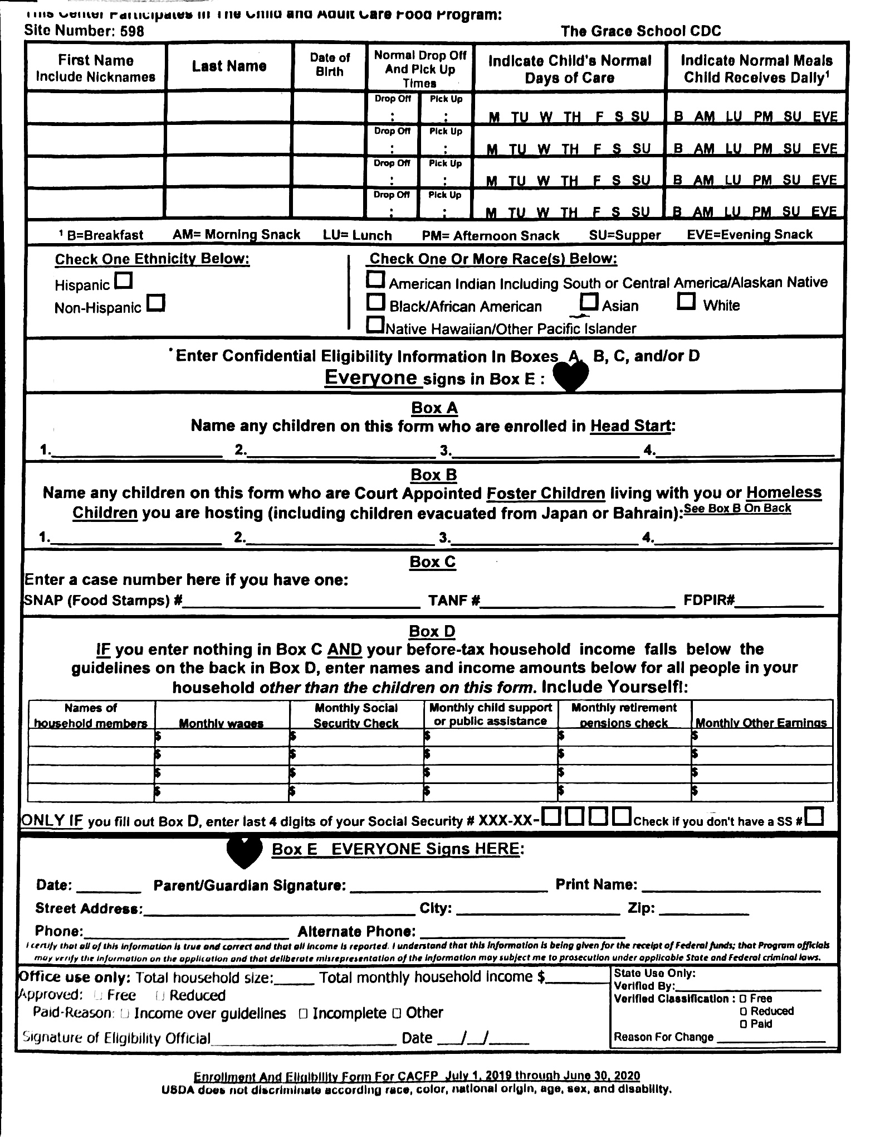

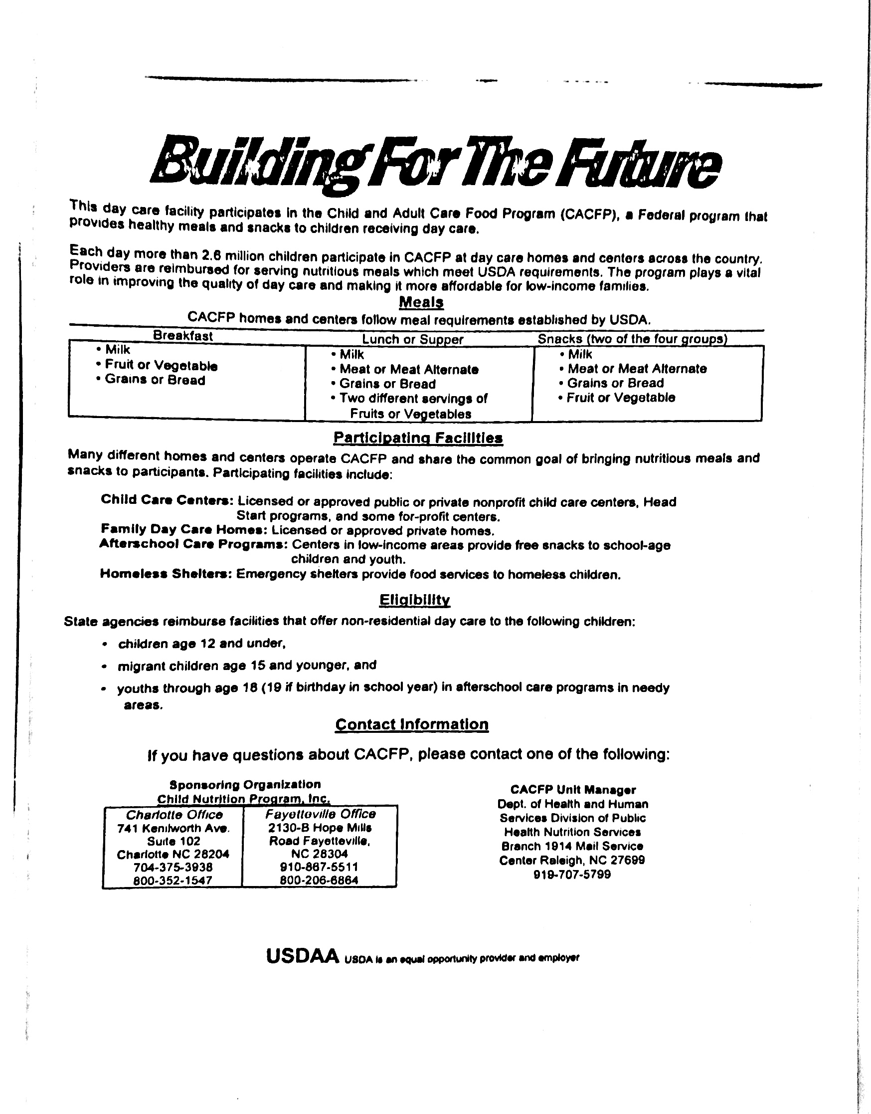

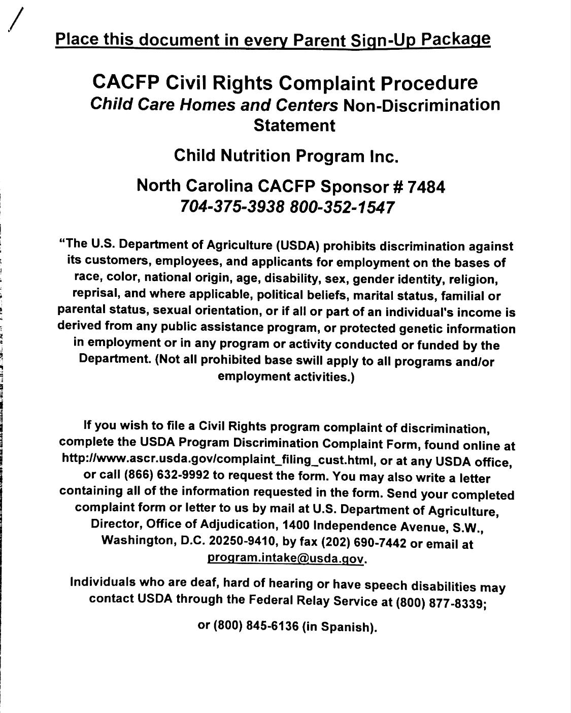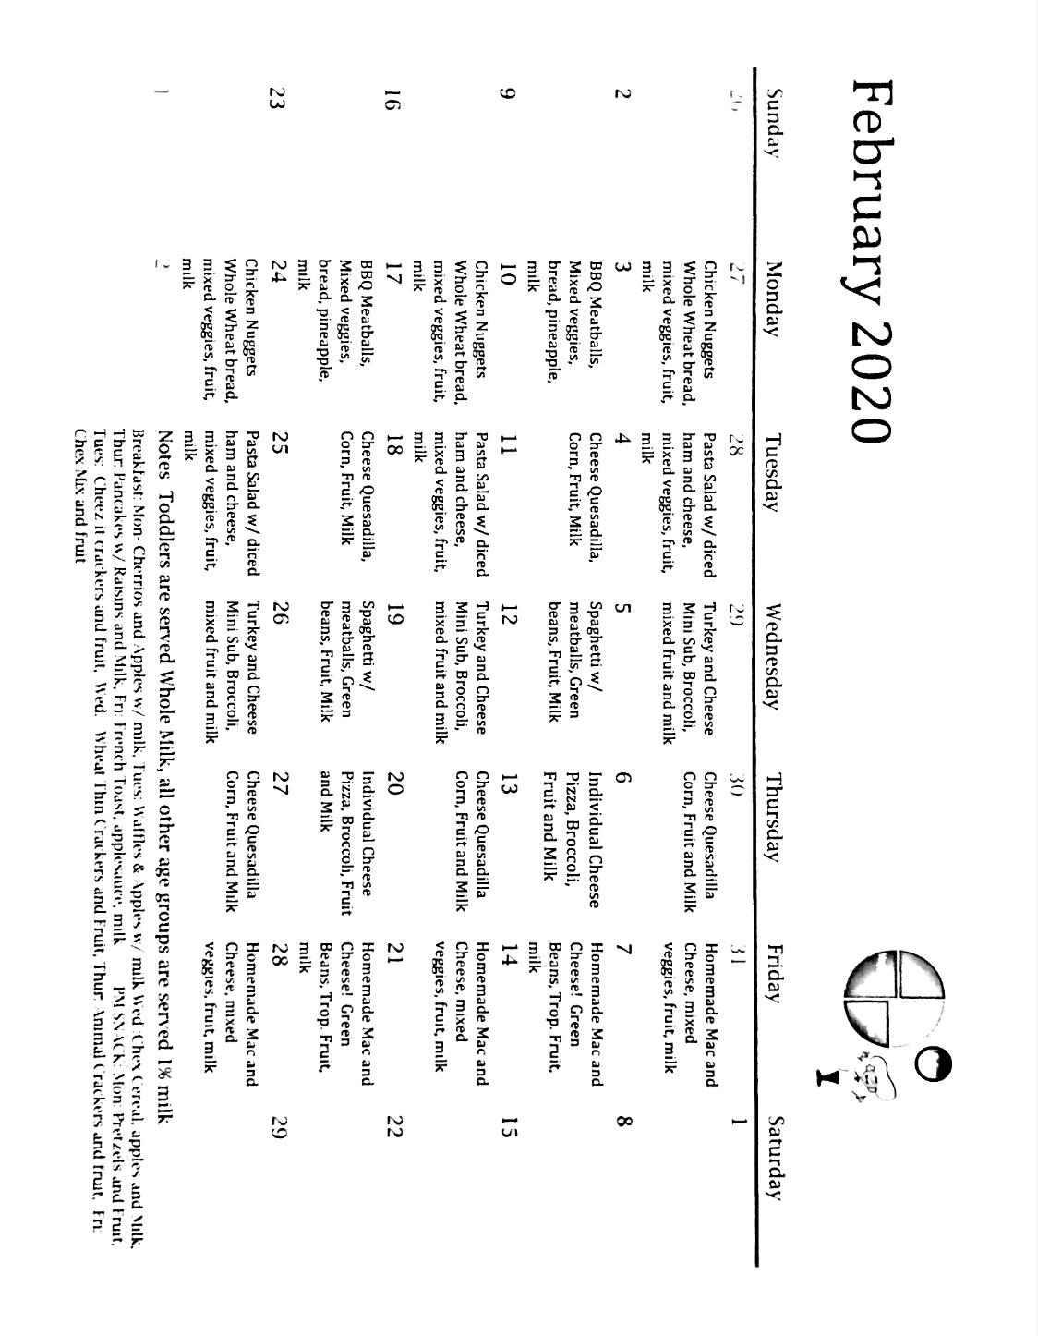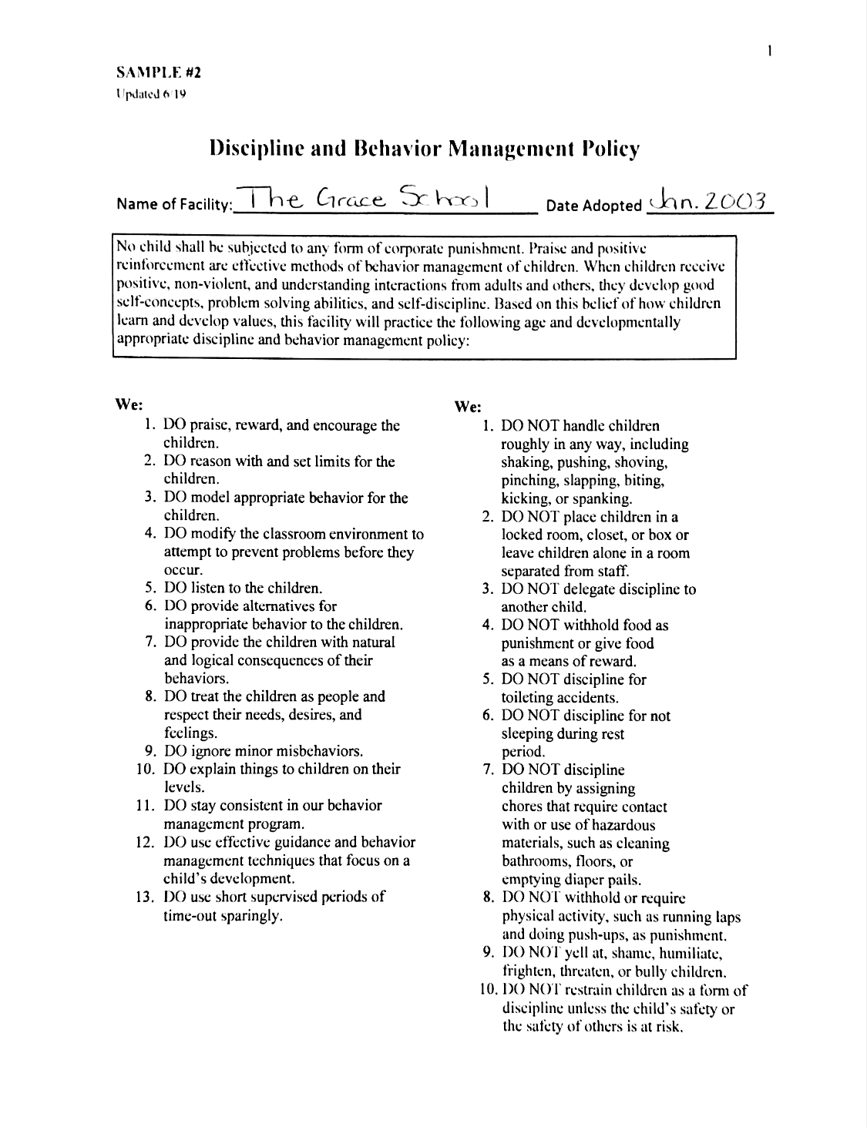

**Illness/Medication**

You have the best insight into your child and their health, and we trust that you will recognize when your child becomes ill. Any child who is ill should not be sent to the center. However, if your child becomes ill while in our care, such as they begin to display an unknown rash or they start acting out of character, your child’s teachers will consult with the director and you may be called to take your child home. When you are called, you (or an alternate emergency person - whose information should be shared with the teacher or director at the time of notification) are expected to come immediately.

Children who have a fever or symptoms of a contagious disease (such as diarrhea, vomiting, eye redness, eye discharge, scabies, pinworms, or lice), or children who have been exposed to a contagious disease among family members, should not be at the center. Depending on the severity or nature of the illness, a doctor’s statement may be required before a child is allowed to return to the center. Parents/guardians should notify the center when their child will be absent due to illness. **In order to return to the center, a child must be fever-free for 24 hours** (*without the use of fever reducers*) **and must wait 24 hours after the last episode of diarrhea or vomiting before returning to school.**

Below are the guidelines from the North Carolina Division of Child Development and Early Education regarding health conditions that require children to be excluded from care:

* Fahrenheit temperature over 100 degrees underarm, 101 degrees orally, or 102 degrees rectally
* Sudden onset of diarrhea characterized by an increased number of bowel movements compared to the child’s normal pattern and with increased stool water
* Have a red eye with white or yellow discharge ***until 24 hours after treatment***
* Have scabies or lice
* Have known chickenpox or a rash suggestive of chickenpox
* Have tuberculosis ***until a health professional states that the child is not infectious***
* Have strep throat ***until 24 hours after treatment has started***
* Have pertussis, ***until 5 days after appropriate antibiotic treatment***
* Have hepatitis A virus infection, ***until 1 week after onset of illness or jaundice***
* Have impetigo ***until 24 hours after treatment***
* Have a physician or other health professional’s written order that the child be separated from other children

If a physician puts your child on an antibiotic for an illness, ***the child must be on the antibiotic for 24 hours before returning to the center***. We will administer mediation, as long as it meets the following requirements:

* If the medication is a prescription, it must have the child’s name on the bottle. (***Do not bring a sibling’s medication.***)
* If the medication is over the counter, the child’s age and weight must be on the box. We will not administer any medication intended for an adult or older child to a preschool-age child.
* A medical slip must be completed by the parent/guardian giving specific instructions for administering the medication.

**Emergency Procedures**

Our center has emergency plans for different situations. We have a fire plan, a severe weather plan, and a lock-down or intruder plan. We have monthly drills for the fire plan and quarterly drillers for the lock-down/shelter-in-place plan. During each drill, the lead teachers check to make sure no children are left behind while they are evacuating the building, and they bring the attendance record to the meeting place to ensure all children are there. We do have an emergency response plan, should the need to evacuate the facility ever occur. With this plan, we will evacuate all classrooms and stay at Real Life Church where we will then begin making contact with the families of the children.

**Family Involvement Opportunities**

Here at The Grace School, we hold on open-door policy! Families are welcome and encouraged to participate in classroom activities on a regular basis. We have planned special events during the holidays, and we often have picnics with families during the spring and summer. Besides these activities, we encourage you to spend as much time in your child’s classroom as your work schedule will allow.

We also have periodic Family Conferences to discuss your child’s development and how they are doing in the learning environment. These are wonderful opportunities to sit down with your child’s teacher and compare in-depth how the child is doing and discuss ways to connect the home and the learning environment to ensure that the child has opportunities in all environments to further their development.

**Fee Policies**

**Enrollment Fee**

As previously stated, we do have a $45 enrollment fee to secure a place for your child in a classroom for their age or on our waiting list.

**Tuition**

Tuition is due on Monday morning and must be paid no later than 12:00 pm on Tuesday in order to avoid a late fee. Please remember that we depend on your child’s tuition payment to meet the expenses of running a high-quality program for you and your child to enjoy, so we thank you in advance for paying your tuition on time.

Of course, we do understand that occasionally life happens and things don’t always go as planned, so please feel free to come and talk with Ms. Amy about any special circumstances as they arise.

**Tuition Rates**

Infants …………………………………… $238

Toddlers …………………………………. $225

Two’s ………....………………………….. $220

Threes - Fives ………………………........ $210

After School …………………………….. $85

Before & After School ………………….. $95

Summer Camp (K-5) ……………………. $150

**Late Fees**

If you missed our tuition payment period from Monday to Tuesday at 12:00 pm, then a $5 late fee will be added each day to your account.

If you are going to be late in picking up your child without previous notification, you will be charged $1 per minute after 6:05 pm.

Additionally, if your payment can not be processed through Tuition Express, there will be a $25 charge to your account. After two attempts, a cash payment will be due on the day that you are notified. Full-time tuition is due every week rather or not your child attends.

**What to Bring to School**

**Infants:**

* Pack and Play size crib sheet
  + One for each day, since dirty sheets will be sent home daily
* Bottles that are labeled with your child’s name and the date
  + We offer Gerber Good Start formula, so if you choose to use it, a bottle is required for each feeding. We ***can not*** wash and re-use bottles.
  + Diapers
  + Wipes
  + Pacifiers (if needed) - one with a clip and one without a clip
  + Change of clothes - at least 2 to 3 complete changes
  + Diaper cream
    - Is considered a medication and ***must*** include a mediation slip

**Toddlers:**

* Standard size crib sheet for cot
* Diapers
* Wipes
* Blanket for rest time
* Change of clothes - at least 2 changes

* Children must wear hard-soled shoes daily

* Sippy cup sent in daily for milk that is labeled with your child’s name and the date

**Two’s:**

* Standard size crib sheet for rest time
* Blanket for rest time
* Change of clothes - at least 2

* If your child is going through potty training, they may require more changes of clothes and at least one extra pair of shoes

* Diapers or pullups
* Wipes
* Cup or water bottle

**Three’s and Pre-K:**

* Standard size crib sheet for rest time
* Blanket for rest time
* Change of clothes - at least 2

*Occasionally we will ask for water shoes and a hat depending on the weather.

\**We ask that children do not bring toys from home as this can cause a disturbance in the classroom*, and we do not want to be responsible for broken toys.

**Appropriate Dress and Participation**

Please dress your child in play clothes to come to school. Learning can sometimes be very messy. We also ask that children wear***closed-toe shoes******every day*** in order to prevent foot injuries on the playground.

Please make sure that your child has a coat when the weather gets cold. We will go outside unless there is a weather advisory or active precipitation. All classrooms have a weather chart to determine rather it is safe to take the children outside.

**Curriculum and Classroom Activities**

Our infant and toddler classrooms utilize The Creative Curriculum, which is a research-based curriculum approved by the Division of Child Development and Smart Start. The Creative Curriculum provides teachers with the flexibility to develop individualized and group lesson plans in order to meet each child’s developmental needs. Developmental assessments are completed periodically to assess children’s needs. Families are encouraged to communicate with their child’s teacher regarding developmental concerns.

Our two year old through Pre-K classrooms utilize Mother Goose Time, which is a play-based curriculum approved by the NC Division of Child Development and Early Education. It provides learning opportunities in all areas of development through a variety of hands-on S.T.E.A.M. (Science, Technology, Engineering, Art, and Mathematics) activities.

** **None of our classrooms or curricula utilize or send home worksheets, as we believe that children learn best through play and meaningful experiences with their teachers, peers, and materials to help promote their development.**

**Outdoor Play Guidelines**

Playing outdoors is an exciting part of a child’s day. During outdoor time children have the freedom to run, jump, skip, and be as loud as they desire. Depending on weather conditions, we take the children outside two times daily, once in the morning and once in the afternoon.

In addition to playground activities, children take nature walks and play organized sports such as soccer.

**Safe Arrival and Departure Procedures**

Parents/guardians must accompany their child to their classroom upon arrival and sign their child in every day. They are required to take their child to wash their hands prior to interacting with materials or other children. Please make sure that the teacher on duty is aware of your child’s presence in the classroom before leaving.

When arriving to pick up your child, please make sure that you check your child’s cubby and classroom communication center for the end of the day information. Parents/guardians must sign their child out prior to leaving. If someone else will be picking up your child, please make sure that they are listed on your child’s application, otherwise, we will require a note sent from home that indicates the name of the person who will be expected to pick up. In an emergency situation, we will accept a phone call from the family if someone else needs to be sent. We will check identification when someone other than the parent/guardian picks up the child.

